Project Name |  | Confidentiality Level
XX Project |  | For Recipients’ Reference Only
Project ID | Version | Document Code

Contract Management System
Project Start Report

15301002 程 辰
15301009 倪施杰



Copyright © Ruankosoft Technologies (Shenzhen) Co., Ltd.
All Rights Reserved
Revision Record
Date | Revision Version | CR ID /Defect ID | Sec No. | Change Description | Author

Content
1. Project Proposal 5
2. Team building and Schedule 5
3. Risks Evaluating and Mitigating 5

Keywords:
Contract ,Process, Permission
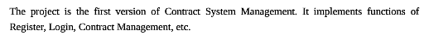
Abstract :

List of abbreviations :
Abbreviations | Full spelling | Chinese explanation

Project Proposal
1. Project ID:

2. Project Introduction: 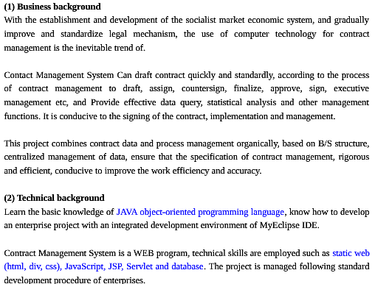
3. Project objective: 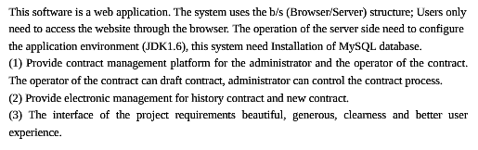
4. System boundary:
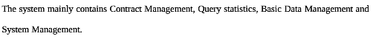

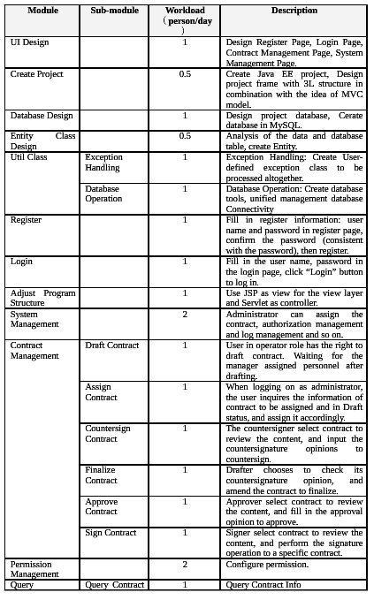
5. Workload assessment:

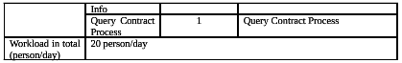

Remarks: Person/day means workload of the number of person & day

Team building and Schedule
1. Project Plan： 2017.5.24——2017.6.15

2. Chief Project Manager： Number：15301002 Name：程辰

3. Project Team Member ： Number：15301009 Name:倪施杰

Risks Evaluating and Mitigating
